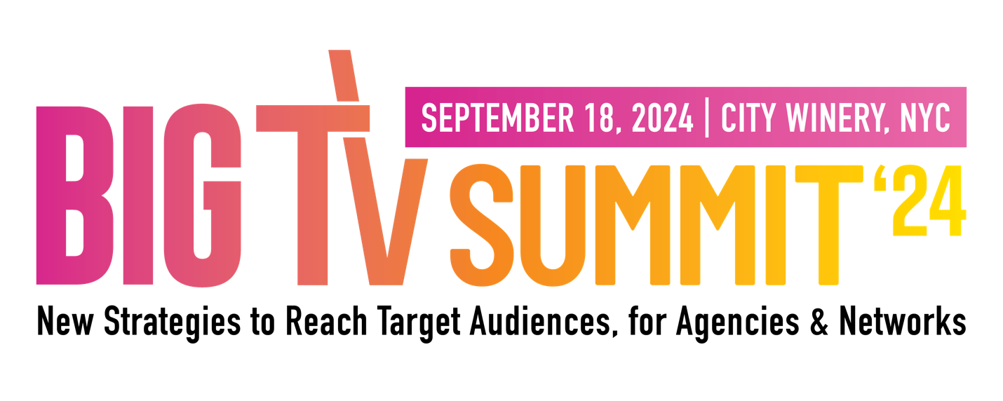

Dear [Boss’s Name],

I’m writing to request approval to attend the Cynopsis BIG TV Summit. In just one day, I’ll gain the tools and actionable strategies to plan for the year ahead — knowledge I can implement as soon as the day after the conference. The conversations that happen at the BIG TV Summit will help me identify the platforms and networks where our ad spend will reap the biggest ROI.

Why right now? Here are three big reasons:

- An increasing number of TV viewers are accepting advertising in streaming video, according to Hub Entertainment Research, with 68% of TV viewers preferring to watch ads if it saves on subscription costs. This means more opportunity to be seen.
- $379 billion in U.S. ad spend is expected this year — I’ll hear directly from decision-makers on where we should be spending our (and our clients’) money.
- 47% of marketers worldwide are saying they trust AI with ad targeting. JCPenney, KERV Interactive, and DentsuX will be at the event discussing ways we can leverage AI for hyper-targeted messaging, overcoming cookieless challenges, and maximizing our ROI. I’ll also learn how AI is transforming media buying and measurement.
Plus, major brands, agencies, and networks across the US, such as GroupM, PepsiCo, UM, and Digitas, could be sitting at my table. BIG TV Summit is a community gathering where I’ll be able to build relationships and learn from industry leaders — as well as our competitors — to be smarter, and better, at my job.

Tickets are currently $599 but increase to $749 on Friday, August 16.

Thank you for considering this request. I look forward to receiving your approval.

Best,

[Name]

